J13. HARDING & BILLING SERIES. [n.l. 1905]

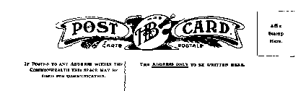
Pu Harding & Billing, Sydney (Cook 1986,
pp. 1J6-8)
F Photograph printed in Bright Red
(J13A), Green (J13B) or B & W (J13C) with title in broad white margin at R.H. or in
lower margin.

J13A
J13A.1 Jenolan Caves, N.S.W. H with R.H. title, depicts Madonna Cave [pm.9 Nov.1905]
J13A.2 Jenolan Caves, N.S.W. H with bottom title, depicts Wilkinson Branch.
J13A.3 Jenolan Caves, N.S.W. H with bottom title, depicts another view of Wilkinson Branch; picture is inverted.
J13A.4 Jenolan Caves, N.S.W. H with bottom title, depicts Shawl Chamber, Imperial Cave
J13A.5 Coral Grotto, Jenolan Caves, N.S.W. H with R.H. title. [p.m.4 Apr.1905]
J13A.6 The Willows, Jenolan Caves, N.S.W. H with R.H. title [pm. 16 Dec 1906]

J13B
J13B.1 Jenolan Caves, N.S.W. H with R.H. title, depicts Madonna Cave [pm.9 May 1905]
J13B.4 Jenolan Caves, N.S.W. H with bottom title, depicts Shawl Chamber, Imperial Cave [pm.15 Mar.1905]
J13B.5 Coral Grotto, Jenolan Caves, N.S.W. H with R.H. title. [pm.27 Feb 1905]
J13B.6 The Willows, Jenolan Caves, N.S.W. H with R.H. title [pm.19 Mar.1905]

J13C.
J13C.3 Jenolan Caves, N.S.W. H with bottom title, depicts Wilkinson Branch ; picture is inverted.

